How to submit an application to create a new society at CSU
- Go to: https://portal.hellorubric.com/getstarted
- Enter your student email address (this will be changed later to your new society email if successful)
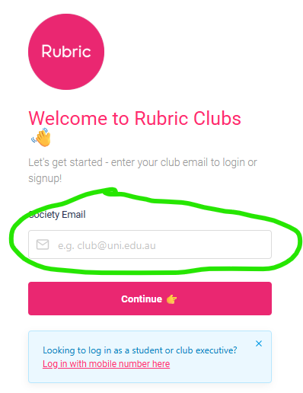
- Complete all fields including:
- Society name
- Short society description
- Search for University of Chester
- Type of society (if you’re not sure just pick the closest for now)
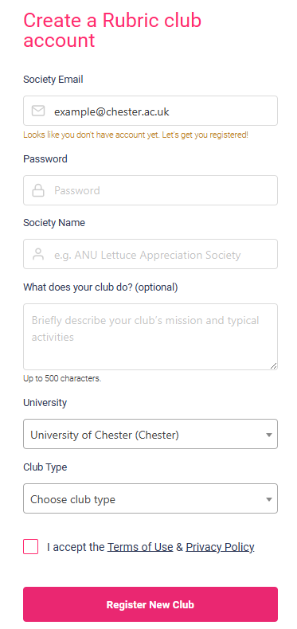
Then click register your new club. You will be asked to enter a verification code sent to the email address you provided. Following this you’ll have a new society dashboard created.
- On the society dashboard click ‘forms’ at the top menu bar.
- Click new society application
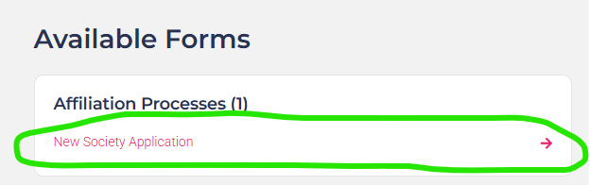
- Then click ‘submit form’ to complete the questions from CSU.
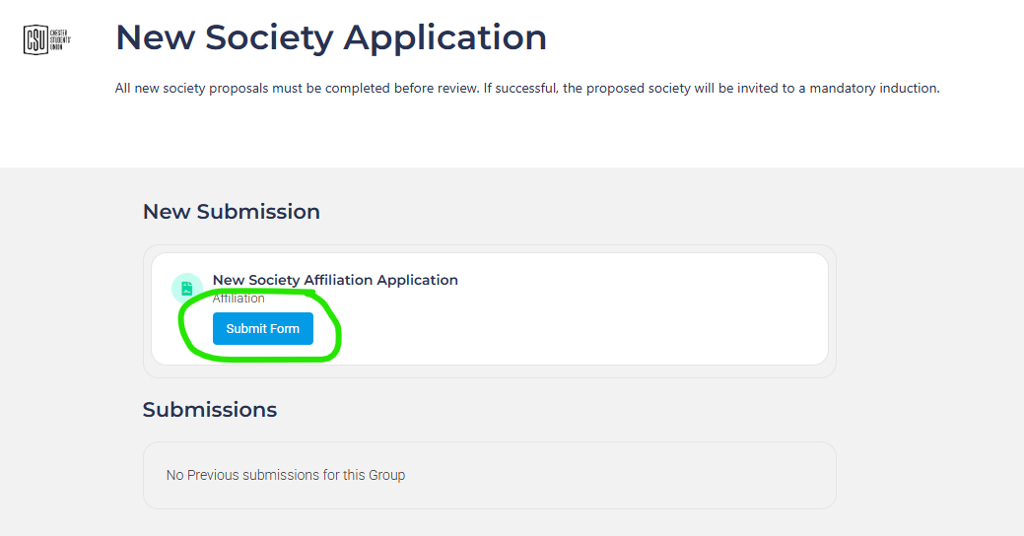
- Once completed, submit your form.
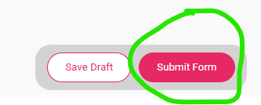
- Your application will be reviewed, and you will hear from the student opportunities team within 10 working days.

